**Project Design Phase-II**

**Technology Stack (Architecture & Stack)**

|  |  |
| --- | --- |
| Date | 29 - June-2025 |
| Team ID | LTVIP2025TMID30749 |
| Project Name | HealthAI: Intelligent Healthcare Assistant Using IBM Granite |
| Maximum Marks | 4 Marks |

**Technical Architecture:**

The Deliverable shall include the architectural diagram as below and the information as per the table1 & table 2

Guidelines:

Include all the processes (As an application logic / Technology Block)

Provide infrastructural demarcation (Local / Cloud)

Indicate external interfaces (third party API’s etc.)

Indicate Data Storage components / services

Indicate interface to machine learning models (if applicable)

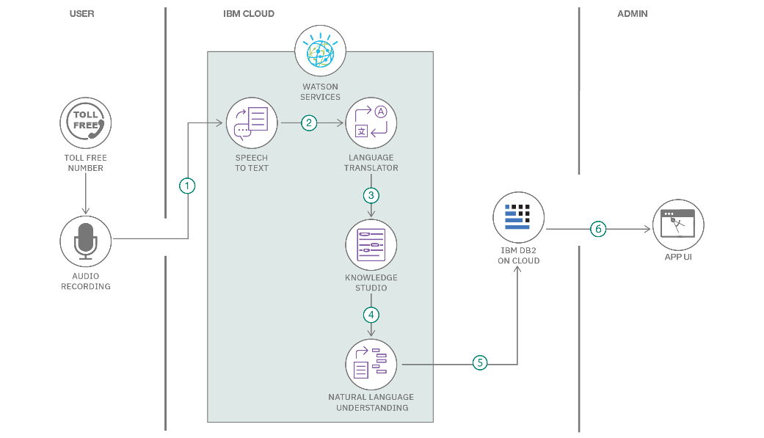

**Table-1 : Components & Technologies:**

|  |  |  |  |
| --- | --- | --- | --- |
| **S.No** | **Component** | **Description** | **Technology** |
|  | User Interface | How user interacts with application e.g.  Web UI, Mobile App, Chatbot etc. | Stremlet |
|  | Application Logic-1 | Logic for a process in the application | Python |
|  | Application Logic-2 | Logic for a process in the application | IBM Watson STT service |
|  | Application Logic-3 | Logic for a process in the application | IBM Watson Assistant |
|  | Cloud Database | Database Service on Cloud | IBM DB2, IBM Cloudant etc. |
|  | File Storage | File storage requirements | IBM Block Storage or Other Storage Service or Local Filesystem |
|  | External API-1 | Purpose of External API used in the application | IBM Weather API, etc. |
|  | Machine Learning Model | Purpose of Machine Learning Model | Object Recognition Model, etc. |

**Table-2: Application Characteristics:**

| **S.No** | **Characteristics** | **Description** | **Technology** |
| --- | --- | --- | --- |
|  | Open-Source Frameworks | List the open-source frameworks used | Technology of Opensource framework |
|  | Security Implementations | List all the security / access controls implemented, use of firewalls etc. | e.g. SHA-256, Encryptions, IAM Controls, OWASP etc. |
|  | Scalable Architecture | Justify the scalability of architecture (3 – tier, Micro-services) | IBM Granite |